**CIS 375 – Fall 2019 Term Project - BRAINS**



Use Case Specification Document

**2**

**Login and Account Interaction**

**Version No. 1.2.0**

**Project Document Revision History**

|  |  |  |  |
| --- | --- | --- | --- |
| **VersionNumber** | **Date** | **Revision Author** | **Description of Revision** |
| 1.0.0 | 10/27/2019 | Kevin Longwroth | Creation of document |
| 1.0.1 | 10/28/2019 | Kevin Longworth | Revision of table of contents formatting |
| 1.1.0 | 10/30/2019 | Kevin Longworth | Edited swimlane diagram |
| 1.1.2 | 11/7/2019 | Kevin Longworth | Updated diagram and flows |
| 1.2.0 | 12/13/2019 | Muaz Alhaidar | Updated swimlane diagram, and adjusted flows to match |

|  |
| --- |
| **Table of Contents** |

1. Introduction 4

2. Use Case Information 4

2.1 Actors 4

2.2 Use Case Interaction 4

3. Trigger 4

4. Pre-condition(s) 4

4.1 The user must already have a login in order for this use case to be done successfully 4

5. Post-condition(s) 5

5.1 The user logs in successfully 5

5.2 The user enters in the wrong credentials and is rejected 5

6. Use Case Swimlane (Activity) Diagram 5

7. Main/Basic Flow(s) of Events (Happy Path) 6

7.1 The user logins, and is able to access the process he has rights to. 6

8. Alternate/Exception Flow of Events 6

8.1 User is rejected 6

9. Assumptions/Business Rules including Non-Functional Requirements 6

10. Use Case Specification Review and Signoff 7

# Introduction

This use case goes over the process of users logging in, as well as how new accounts will be created for more users to use the software. The user can request a login and the oversight team will give each user access level and what STENER they will see depending on what department they are a part of.

# Use Case Information

## Actors

An actor is someone or something (e.g. application system) outside the system or business that interacts with the application. For every Use Case, there must be at least one Main Actor and zero or more Secondary Actors. Actors should be a person, system, or time.

|  |  |  |
| --- | --- | --- |
| Actor Name | Role | Description |
| Oversight team | Main | They will be logging in to their Oversight Interface |
| Departments | Main | Using the login system to enter department interface, answer the STENERs, and look at violations |
| Database | Secondary | This will be saving the data for each login, and relaying the proper credentials when trying to login |

## Use Case Interaction

How does this use case relate to other uses cases? List predecessor and successor use cases.

This use case precedes all other use cases, because in order to access the other use cases, the user must login to the system.

# Trigger

What causes the use case to initiate?

Starting up the software will trigger this use case to begin.

# Pre-condition(s)

What use cases or other pre-conditions must be met before use can initiate?

## The user must already have a login in order for this use case to be done successfully

# Post-condition(s)

What are ALL the possible output states upon completion of the use case flows?

## The user logs in successfully

## The user enters in the wrong credentials and is rejected

# Use Case Swimlane (Activity) Diagram

Draw diagram(s) that cover ALL main and alternate flows.

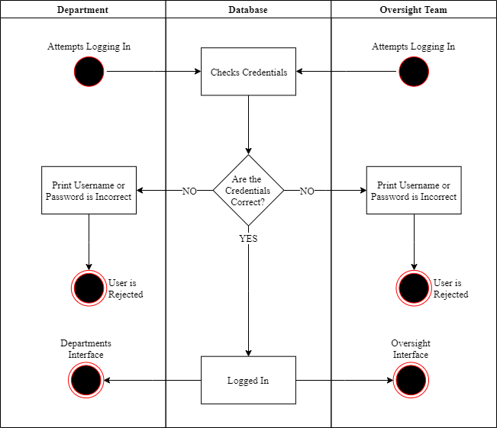

# Main/Basic Flow(s) of Events (Happy Path)

For each main flow (usually ONE flow) write the list of steps that occur – describe WHAT occurs not HOW to do it!

## The user logins, and is able to access the process he has rights to.

* + 1. Department/Oversight user attempts to login
    2. Database checks credentials
    3. Credentials are correct
    4. User is logged in
    5. If Departments: Enter Departments Interface
    6. If Oversight: Enter Oversight Interface

# Alternate/Exception Flow of Events

For each alternative flow (can be zero or more) write the list of steps that occur – describe WHAT occurs not HOW to do it!

## User is rejected

* + 1. Department/Oversight user attempts to login
    2. Database checks credentials
    3. Credentials are not correct
    4. Print that username or password is incorrect
    5. User is Rejected

# Assumptions/Business Rules including Non-Functional Requirements

Each user will have a different access level depending on who they are with. It is also assumed that only people on the oversight team will have access to the oversight page.

# Use Case Specification Review and Signoff

|  |  |  |  |
| --- | --- | --- | --- |
| Review and Signoff of the Use Case Specification | | | |
| Name | Project Team Role | Signature | Date |
| Ahmed, Zakariya | Senior Tech Lead/SPMP manager | Z.A. | 12/13/19 |
| Alhaidar, Muaz | Developer | M.A. | 12/13/19 |
| Longworth, Kevin | Developer | K.L. | 12/13/19 |
| Labut, Cameron | Developer | C.L. | 12/13/19 |
| Majzoub, Mostafa El | Developer | M.M | 12/13/19 |